my-insurer voted the best marketing tool for insurance intermediaries in Singapore

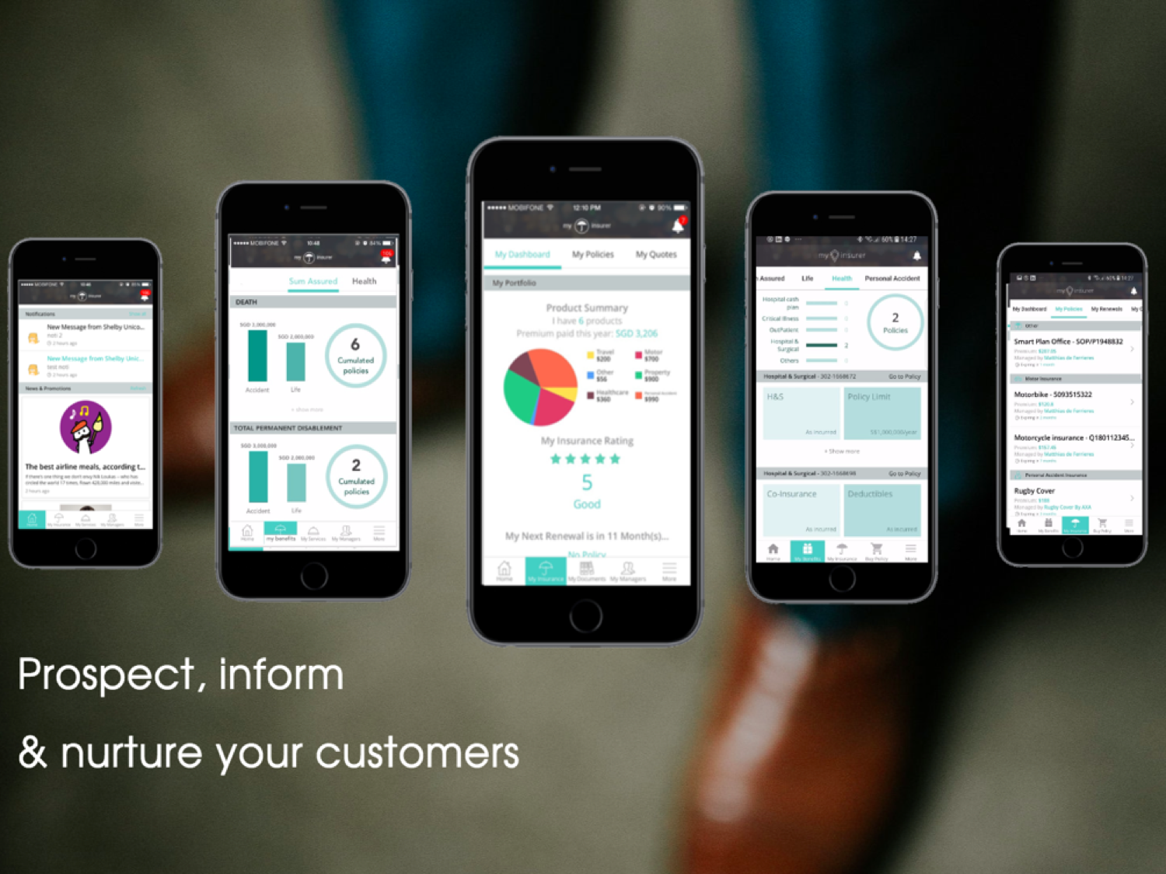

my-insurer; the first of its kind application for both intermediaries and policy holders was officially launched on 26 September at InsurByte 2017.

The software -that comes with an app- is a pioneer enabler for insurance intermediaries to better manage, communicate and facilitate sales between them and their policyholders.

Aimed at making their business process more efficient, the daily activities of an intermediary is now housed under one roof; where they can send/receive quotations/renewals/claims, track and manage sales/marketing activities.

To date, my-insurer partnered with over 400 intermediaries in Singapore and Malaysia; mostly life agents and independent financial advisers. They come from the main insurance players - AXA, Great Eastern, Prudential, AIA, Manulife….

Since launch and on behalf of its partners, it has more than 17,000 policyholders, 22,000 effective policies and a booked a premium worth SGD$140 million.

In October and November, Regine Lai, MD of my-insurer launched a round of discussions with the different insurance intermediaries in Singapore. She questioned over 100 Life agents and Financial Advisors both online and offline on the usability of her system.
The results are overwhelming!
my-insurer is pleased to be voted Singapore’s best marketing tool for insurance intermediaries.

It has gathered an overall score of 8.5/10 on the following key items that makes a marketing CRM successful:
1. Ease of use
2. Effectiveness
3. Sales conversion
4. Lead generation
5. Relevancy
6. Customer engagement
7. Marketing and communication

For 95% of them, my-insurer was in their TOP 3 for the most relevant and powerful tool to use for managing their insurance portfolio.
As a pre & post acquisition software, 80% confirmed that my-insurer is not only the number 1 for their day to day activities but also the only system that focuses on the insurance intermediation.

Regine Lai has committed to conducting further surveys and focus groups in the coming months to facilitate in depth understanding of the challenges and requirements faced by intermediaries.

Matthias de Ferrieres, founder of my-insurer is very proud of such results derived within a short time.
“With such positive feedback and suggestions from the one that makes the industry, it is rewarding and encouraging. We are the first that brings a true value proposition to the insurance distribution by inviting intermediaries to digitalise their business. We are confident to bring the insurance industry and our partners to a new era.”

Disrupting the insurance industry - Creative digitalization & innovative distribution

www.my-insurer.net
communication@stark-grp.com

